Donderdag 18 februari 2016, 19.30 uur (deur open vanaf 19.00 uur)

Elleke Boehmer en David Attwell in gesprek met Carrol Clarkson
Elleke Boehmers roman, The Shouting in the Dark, en de biografie van David Attwell over de Nobelprijs-winnende auteur J.M. Coetzee, leveren ons een aantal onderwerpen voor een levendig gesprek over het schrijven van een autobiografie, het persoonlijke en het politieke in romans, de rol van het geheugen, de culturele en koloniale erfenis, Zuid-Afrikaanse literatuur en het creatieve proces van het vertellen van verhalen. Daarover zal Carrol Clarkson met de twee gasten en het publiek in gesprek gaan.

Elleke Boehmer is the Professor of World Literature in English, in the English Faculty at the University of Oxford. She is the author of five highly praised novels, the recent The Shouting in the Dark, as well as Screens again the Sky (short-listed David Hyam Prize, 1990), Bloodlines (shortlisted SANLAM prize), and Nile Baby (2008), and of the short-story collection Sharmilla and Other Portraits (2010). Other books include Colonial and Postcolonial Literature (1995, 2005), the biography Nelson Mandela (2008), Stories of Women (2005), and Indian Arrivals (2015). She edited the British best-seller Robert Baden-Powell’s Scouting for Boys (2004), and the anthology Empire Writing (1998), and has co-edited several books, including J.M. Coetzee in Writing and Theory (2009). A founding figure in postcolonial literary studies, Elleke is currently the Director of the Oxford Research Centre in the Humanities and the General Editor of the Oxford Studies in Postcolonial Literatures Series. She was a Man Booker International judge 2015.

David Attwell is Head of the Department of English and Related Literature at the University of York, having worked at three South African universities before relocating to the UK in 2005. Born in Pretoria, he grew up in Cape Town. He completed his PhD at the University of Texas at Austin. J.M. Coetzee and the Life of Writing is his second monograph on the Nobel laureate. His other books include Rewriting Modernity: Studies in Black South African Literary History, and The Cambridge History of South African Literature, co-edited with York colleague Derek Attridge.

Carrol Clarkson is Professor and Chair in Modern English Literature at the University of Amsterdam. She has published widely on aesthetics, legal theory, and South African literature and art. Her books include J.M. Coetzee: Countervoices and Drawing the Line: Toward an Aesthetics of Transitional Justice. Before coming to Amsterdam she was the Head of Department and Professor in English Literature at the University of Cape Town, South Africa.

Zuid-Afrikahuis Amsterdam
Keizersgracht 141-C
Toegang: € 7,50
Voertaal: Engels
Aanmelden: tel. 020-6249318 of evenementen@zuidafrikahuis.nl
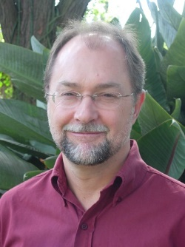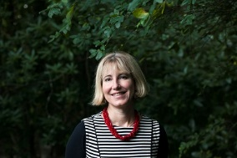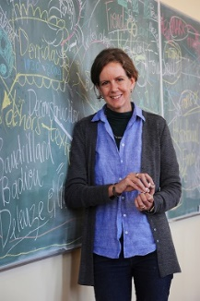
David Attwell Elleke Boehmer Carrol Clarkson

